**All Diagram**

**Process:-**

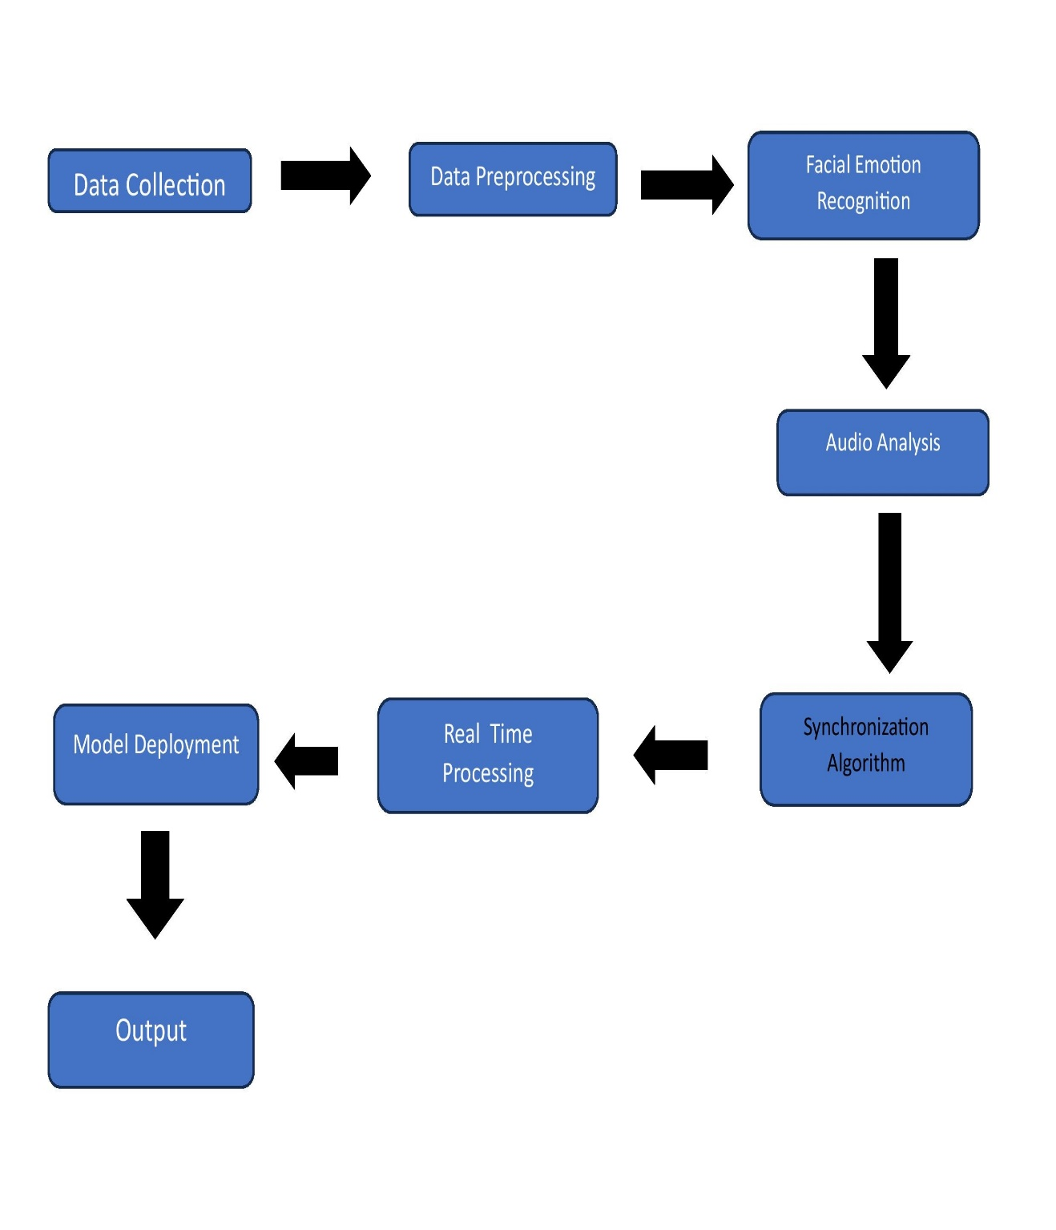

**Use-Case Diagram:-**

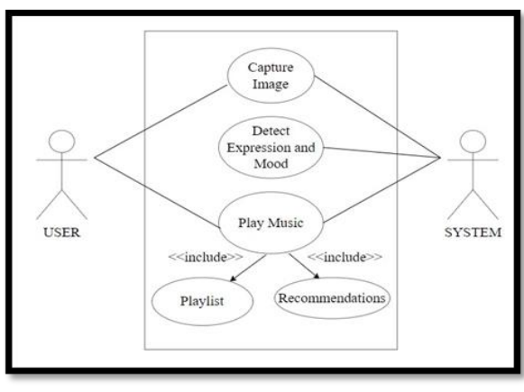

**Data Flow Diagram:-**

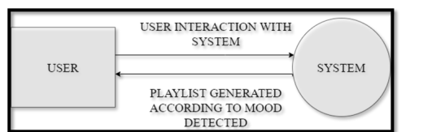

**DFD Level 0**

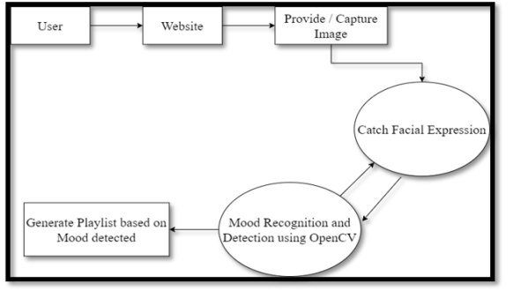

**DFD Level 1**

**Process Flow Diagram:-**

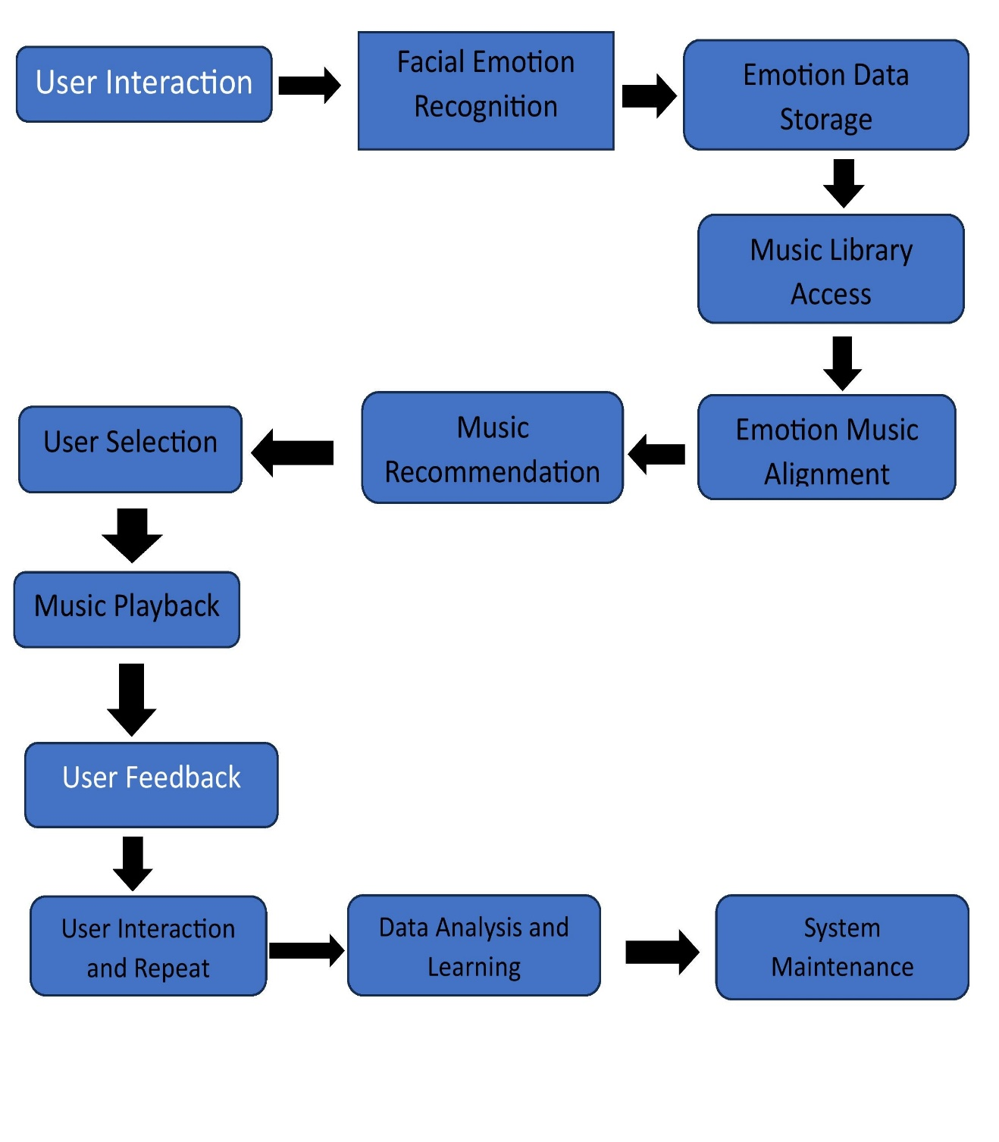

**UML Diagram:-**

